Dynamic Host Configuration Protocol (DHCP)

Use VMware or VirtualBox for virtualization of the servers

Server 1 - Server
Server 2 – Client 1
Server 3 – Client 2

Configure local yum repository or remote epel repository
Select host only networking all the server and client

Login server and become root
Configure the static IP address of server using through "nutui" utility
nmtui

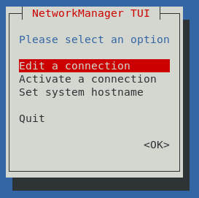

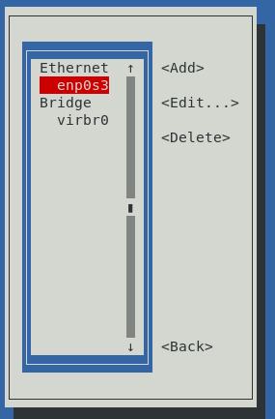

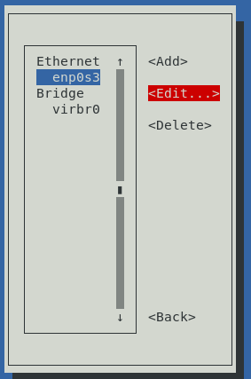

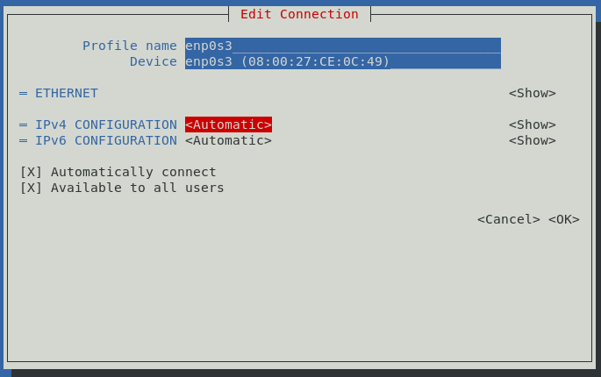

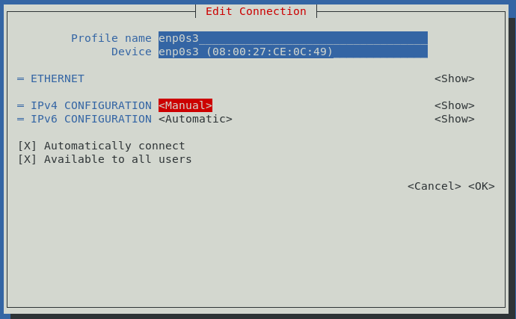

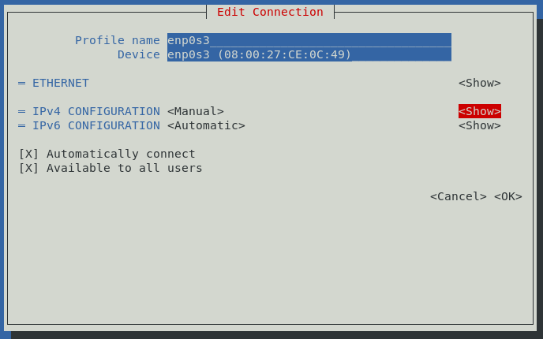

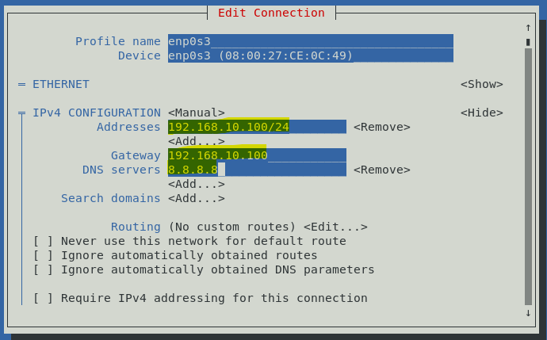

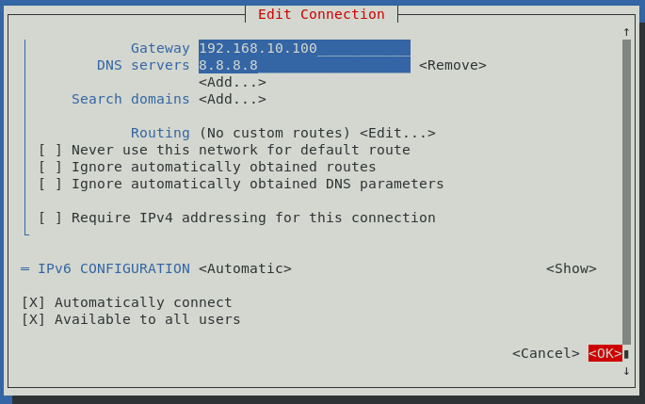

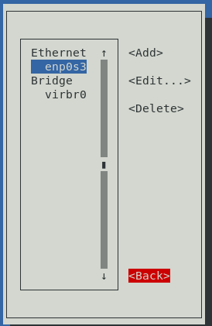

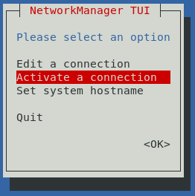

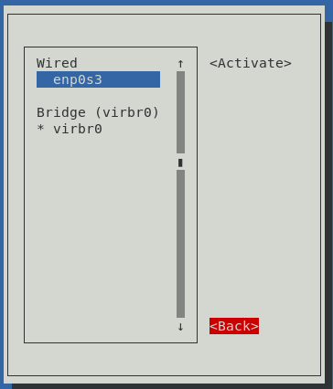

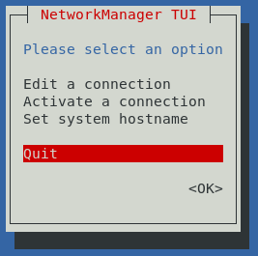

dnf install dhcp-server (RHEL 8 & CentOS 8)
yum install dhcp* (RHEL 7 & CentOS 7)
y
Ping all the server and client from the server. Find the IP address using through "ip a" (or) "ip addr" (or) "ifconfig" utilities
ip a (or) ifconfig
ping 192.168.x.x
cat /etc/dhcp/dhcpd.conf (Find the configuration file)
cat /usr/share/doc/dhcp*/dhcpd.conf.example
cp -r /usr/share/doc/dhcp*/dhcpd.conf.example /etc/dhcp/dhcpd.conf
y
vi /etc/dhcp/dhcpd.conf
Go to the line starts with "A slightly different configuration for an internal subnet".
Change subnet 192.168.1.0
Change netmask 255.255.255.0
Change range 192.168.1.100 192.168.1.200;
Below lines are starts with "option". Comment with # all the lines and save the file
systemctl start dhcpd
systemctl enable dhcpd
systemctl status dhcpd
systemctl stop firewalld
systemctl disable firewalld

Disable the inbuilt DHCP service in VMware

Edit > Virtual Network Editor

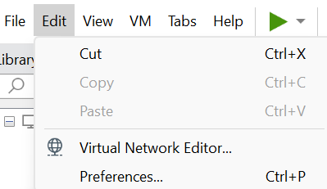

Change Settings

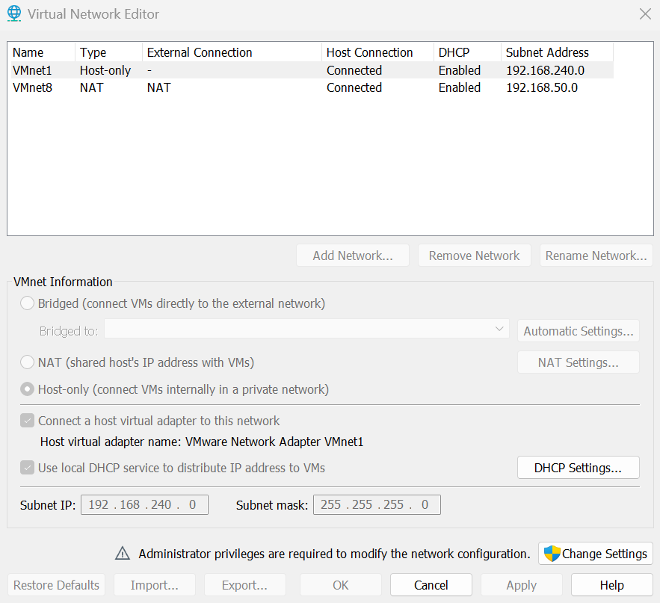

Yes and select the Host-only network

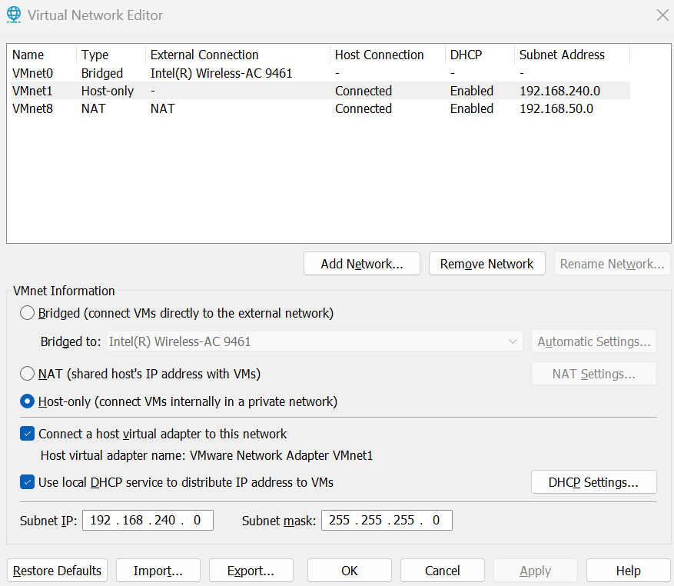

Uncheck Use local DHCP service to distribute IP address to VMs and Apply then OK

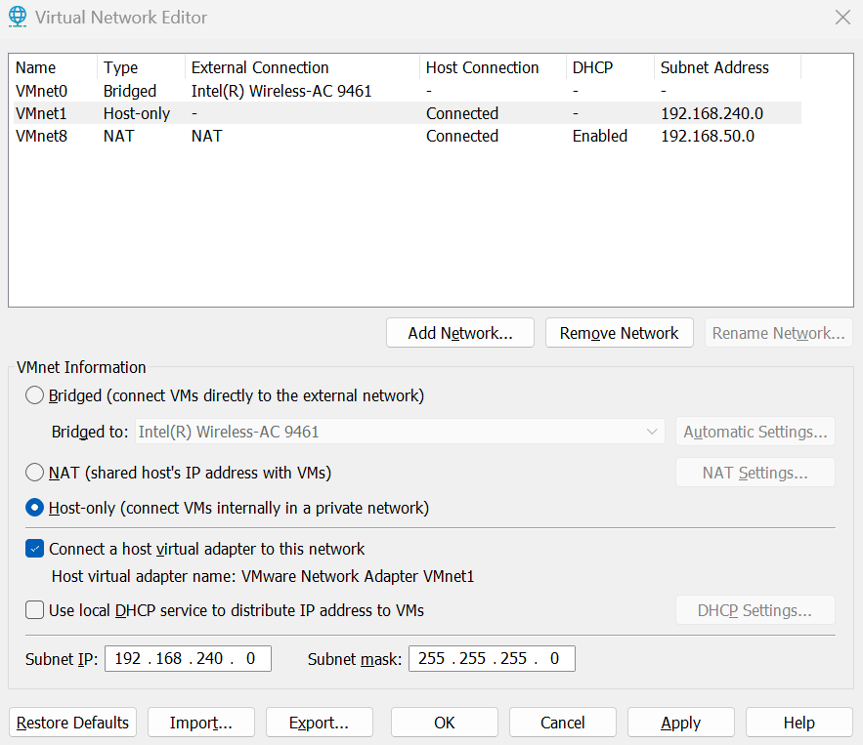

systemctl restart NetworkManager
ip a (or) ifconfig

(or)

Disable the inbuilt DHCP service in VirtualBox

File > Host Network Manager

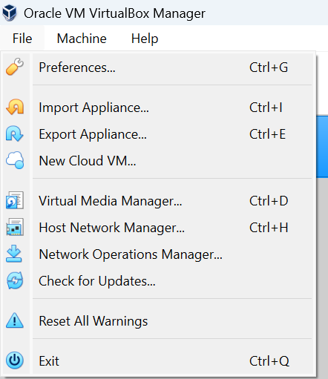

Uncheck DHCP Server and Close

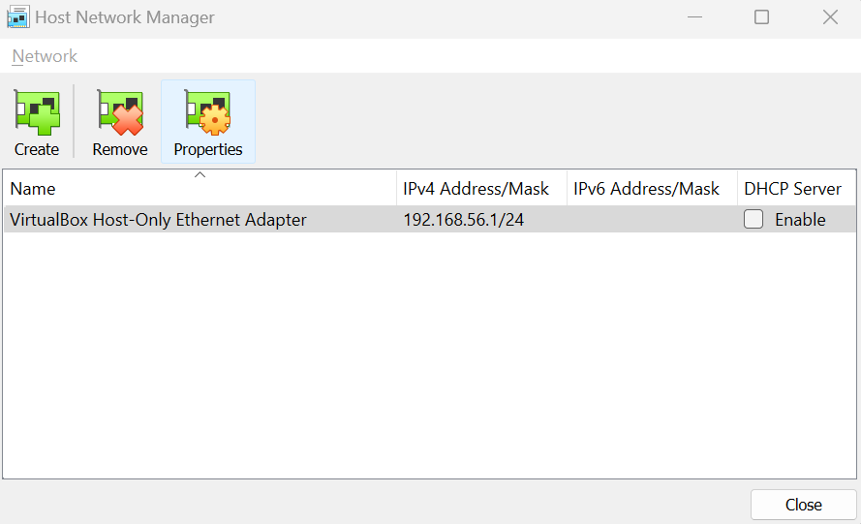

systemctl restart NetworkManager
ip a (or) ifconfig

Login client and become root
systemctl restart NetworkManager
ip a (or) ifconfig (Check the IP address is in the range of DHCP)

Login and check the other clients in the same network

Ping all the clients from the server
vi /etc/dhcp/dhcpd.conf
Change the range of IP's address and save the file (for testing)
systemctl restart dhcpd

Login client and become root
systemctl restart NetworkManager
ip a (or) ifconfig (Check the IP address is in the range of DHCP)

Login and check the other clients in the same network

Ping all the clients from the server
Assign the static IP address to particular client in the network
Set the fixed IP address manually

Login client and become root
ip a (or) ifconfig
Find the Mac address of interface (Example of interface: enp0s3)
(Example of Mac address: ether 00.oc.29:48.oa.cc)

Login server and become root
vi /etc/dhcp/dhcpd.conf
Go to the line starts with "fantasia"
Change "fantasia" with "hostname" of client (Example of hostname: centos7)
Change hardware ethernet xxxxxxxx (Find from the client)
Change fixed-address xxxx; (In the DHCP range)
Save the file
systemctl restart dhcpd

Login client and become root
systemctl restart NetworkManager
ip a (or) ifconfig

